Project Synopsis for Chatbot Framework For College information



Sacred Heart College, Tirupattur

**Department of Computer Science**

|  |  |
| --- | --- |
| Submitted By | Ferdick Nishanth (AU170502)  III Bsc Computer Science |
| Internal Guide | Prof. J. John Arockiaraj |
| External Guide | Mr. James Nirmal |

# **Table Of Contents**

Table Of Contents

Abstract

Introduction

Scope

Chatbot that uses limited set of rules

Chatbot that uses Machine learning

Technology

Chatbot Architecture

Selection of OS

Selection of Software

Creating a Chatbot Language

Database

REST Server

UI and Java Script for WEB UI

CORE NAL/NLU (Machine Learning)

Testing

Advantage

Limitation

Conclusion

Reference

# 

# **Abstract**

Chatbots, or conversational interfaces that can converse with humans using artificial intelligence in messaging platforms. Compared to traditional chats, Chatbots are not handled by human persons, but software is leading through conversations.The goal of the project is to add a chatbot feature and API for RASA

# **Introduction**

Intelligent Chatbot is a project that explores with Artificial Intelligence in the world we live in today. Messaging applications are the #1 most used applications in the world at the moment businesses will be looking to take advantage of this and start to develop their own chatbots. Bots are becoming smarter and faster and will soon become easier to use than a website or app. World believe that in the next few years every major business will have a chatbot to deal with customers basic queries and maybe even go as far as processing full orders. Chatbots have the potential to replace call centres, customers can get their queries answered simply by opening their favourite messaging platform and chatting with a bot.

# **Scope**

The purpose of this project is to showcase the power of chatbots using Machine Learning with RASA Framework. The chatbots should be easy to use, respond in a timely fashion and be all round user friendly. The bots should make the users interaction as easy and fast as possible to ensure that the users time is not wasted and they get what they want without any difficulty.

## **Chatbot that uses limited set of rules**

This kind of bots are very limited to set of texts or commands. They have ability to respond only to those texts or commands. If user asks something different or other than the set of texts or commands which are defined to the bot, it would not respond as desired since it does not understand or it has not trained what user asked. These bots are not very smart when compared to other kinds of bots.

## **Chatbot that uses Machine learning**

Machine learning chatbots works using artificial intelligence. User need not to be more specific while talking with a bot because it can understand natural language, not only commands. This kind of bots get continuously better or smarter as it learns from past conversations it had with people by learning and developing a predictive analytical capabilities just like a human using Artificial intelligence. This Project proposed will be developed using Machine learning chatbots

# **Technology**

A Chatbot refers to a chatting robot. It is a communication simulating computer program. It is all about the conversation with the user. The conversation with a Chatbot is very simple. It answers to the questions asked by the user. During designing a Chatbot, how does the Chatbot speak to the user? And how will be a conversation with the user and the Chatbot is very important. The design of a Chatbot is represented using the diagram as follows

## **Chatbot Architecture**

The process starts with a user's request from web or mobile app using text or speech input (**The proposed Project will be Text based Chatbot**) The user request is recorded by a so-called Natural Language Parser(NLP)/Natural Language Understanding(NLU) and is translated into the programming language of the conversation engine. Following, the conservation engine analyses the question and redirects it to the backend using Data Connector. The Data connector is connected to one or several databases (DB) or information systems (IS), which give the request to the corresponding query. The answers are retrieved from the integrated systems.The following facts are kept in mind during designing a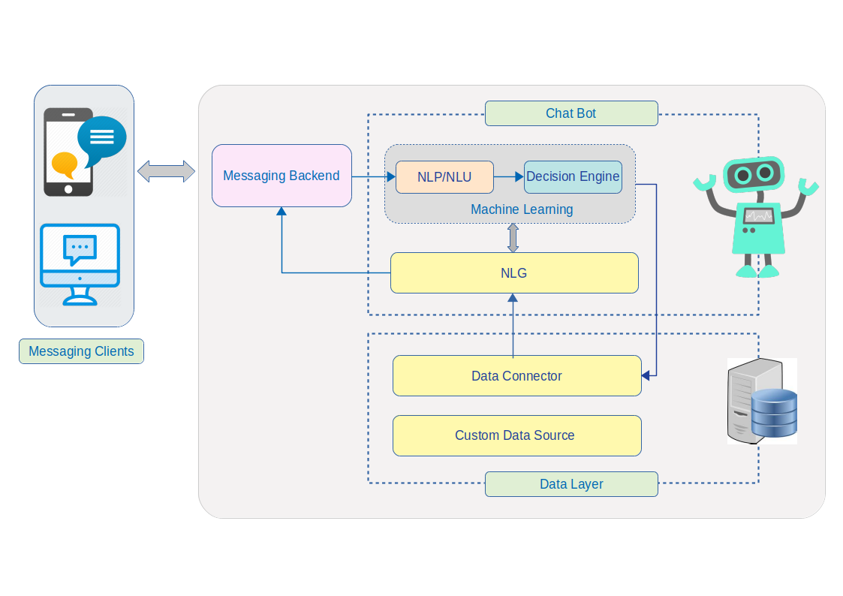

Chatbot.

### **Selection of OS**

Ubuntu Linux is used for this project since it is robust and Open source. Using Ubuntu Linux doesn’t cost a penny. It’s also being adopted at various educational and government organizations across the world to reduce costs. Moreover, most of the software is also free. It also saves the antivirus cost because Its built-in Firewall and virus protection method makes sure the system are protected.

Ubuntu has a strong community support and it’s one of the biggest advantages of Ubuntu over other distros

The recommended hardware requirements are 700 MHz processor, 512MB RAM, and 5GB hard disk.

### **Selection of Software**

Visual Studio Code editor which combines the simplicity of a source code editor with powerful developer tooling.

Visual Studio Code features a lightning fast source code editor. With support for hundreds of languages, VS Code helps the developer instantly productive with syntax highlighting, bracket-matching, auto-indentation, box-selection, snippets, and more. Intuitive keyboard shortcuts.

### **Creating a Chatbot Language**

Python is a general purpose and high level programming language. You can use Python for developing desktop GUI applications, websites and web applications

Python, as a high level programming language, allows you to focus on core functionality of the application by taking care of common programming tasks. The simple syntax rules of the programming language further makes it easier for you to keep the code base readable and application maintainable

Python also features a dynamic type system and automatic memory management. The programming paradigms and language features help you to use Python for developing large and complex software applications.

Python supports many operating systems. You can even use Python interpreters to run the code on specific platforms and tools. Also, Python is an interpreted programming language

Its large and robust standard library makes Python score over other programming languages. The standard library allows you to choose from a wide range of modules according to your precise needs

Python even makes it easier for you to perform coding and testing simultaneously by adopting test driven development (TDD) approach. You can easily write the required tests before writing code and use the tests to assess the application code continuously.

### **Database**

PostgreSQL is the recommended relational database for working with Python web applications. PostgreSQL's feature set, active development and stability contribute to its usage as the backend for millions of applications live on the Web today

PostgreSQL's open source license allows developers to operate one or more databases without licensing cost in their applications.

The most common driver library for working with PostgreSQL is psycopg2

### **REST Server**

Flask is a micro [web framework](https://en.wikipedia.org/wiki/Web_framework) written in [Python](https://en.wikipedia.org/wiki/Python_(programming_language)). It is classified as a [microframework](https://en.wikipedia.org/wiki/Microframework) because it does not require particular tools or libraries

* Contains development server and debugger
* Integrated support for unit testing
* RESTful request dispatching

### **UI and Java Script for WEB UI**

VUE.js The success of JavaScript framework depends on its size. The smaller the size is, the more it will be used. One of the greatest advantages of Vue.js is its small size. The size of this framework is 18–21KB and it takes no time for the user to download and use it.

The user can easily add Vue.js to his web project because of its simple structure. Both the small as well as large scales templates can be developed through this framework which saves a lot of time

A great deal of flexibility is another advantage of Vue.js. It allows the user to write his template in HTML file, JavaScript file, and pure JavaScript file using virtual nodes.

### **CORE NAL/NLU (Machine Learning)**

RASA stack is an open-source AI tool and being an open source framework, It is easy to customize. In fact, In many cases, Clients do not want to share their data and the majority of the tools available are cloud-based and provide software as a service. Rasa can be deploy or host Rasa internally in local environment with complete control on it. Rasa comes up with 2 components

**Rasa NLU** — a library for natural language understanding (NLU) which does the classification of intent and extract the entity from the user input and helps bot to understand what the user is saying.

**Rasa Core** — a chatbot framework with machine learning-based dialogue management which takes the structured input from the NLU and predicts the next best action using a probabilistic model.

**Intent** — Intent is nothing but what the user is aiming for. For example — if the user says “Reserve a table at Cliff House tonight” the intent can be classified as to “book the table”.

**Entity** — Entity is to extract the useful information from the user input. From the example above “Reserve a table at Cliff House tonight” the entities extracted would be place and time. Place — Cliff House and Time — tonight.

**Stories** — Stories define the sample interaction between the user and chatbot in terms of intent and action taken by the bot. Like in the example above bot got the intent of booking the table and entities like place and time but still, there is an entity missing — no of people and that would make the next action from the bot.

**Actions** — Actions are basically the operations performed by the bot either asking for some more details to get all the entities or integrating with some APIs or querying the database to get/save some information.

Understanding (NLU) which comprises of Intent Classification & Entity extraction and create a structured output which can be fed into Rasa Core.

**Rasa Natural Language Understanding (NLU)**

How bot to understand our messages first. For that, we have to train the NLU model with our inputs in a simple text format and extract structured data. We will achieve this by defining the intents and providing a few ways users might express them.

Files must be required to understand Bot

**NLU training file**

It contains some training data in terms of user inputs along with the mapping of intents and entities present in each of them.

**Stories file**

This file contains sample interactions the user and bot will have. Rasa (Core) creates a probable model of interaction from each story.

**Domain file**

This file lists all the intents, entities, actions, templates and some more information. The templates is nothing but the sample bot reply which can be used as an Action.

# Testing

Unit Testing in Python is done to identify bugs early in the development stage of the application when bugs are less recurrent and less expensive to fix. Python Unit Testing mainly involves testing a particular module without accessing any dependent code. Developers can use techniques like stubs and mocks to separate code into "units" and run unit level testing on the individual pieces.

To make the Unit Testing process easier and improve the quality of your project, it is recommended the Python Unit Testing Framework(PyUnit).

**PyUnit:** PyUnit supports fixtures, test cases, test suites and a test runner for the automated testing of the code. In PyUnit, you can organize test cases into suites with the same fixtures

# Advantage

Humans have a limit to the number of clients they can handle at once. However, with chatbots, there is no such constraint and they can handle as many queries as required at once.

Reduced Costs – chatbots eliminate the requirement of any manpower during online interaction and are hence seen as a big advantage by companies receiving multiple queries at once.

24-7 availability – Unlike humans, chatbots once installed can attend queries at any time of the day. Thus, the customer doesn’t have to wait for the company executive to help them.

Learning and Updating – AI-based chatbots are capable of learning from interactions and updating themselves on their own

Multiple Customer Handling – Humans have a limit to the number of clients they can handle at once. However, with chatbots, there is no such constraint and they can handle as many queries as required at once

# Limitation

Complex Interface – Chatbots are often seen to be complicated and require a lot of time to understand user’s requirement. It is also the poor processing which is not able to filter results in time that can annoy people

Inability to Understand – Due to fixed programs, chatbots can be stuck if an unsaved query is presented in front of them. This can lead to customer dissatisfaction and result in loss.

Increased Installation Cost – Chatbots are useful programs that help you save a lot of manpower by ensuring the all-time availability and serving to several clients at once. But unlike humans, every chatbot needs to be programmed differently for a new business which increases the initial installation cost

# Conclusion

A chatbot is one of the simplest ways to transport data from a computer without having to think for proper keywords to look up in a search or browse several web pages to collect information; users can easily type their query in natural language and retrieve information. In this paper, information about the design, implementation of the chatbot has been presented. From the survey above, it can be said that the development and improvement of chatbot design grow at an unpredictable rate due to variety of methods and approaches used to design a chatbot. Chatbot is a great tool for quick interaction with the user. They help us by providing entertainment, saving time and answering the questions that are hard to find.

# Reference

* <https://rasa.com/>
* <https://www.edureka.co/blog/how-to-make-a-chatbot-in-python/>
* <https://medium.com/analytics-vidhya/building-a-simple-chatbot-in-python-using-nltk-7c8c8215ac6e>
* <https://medium.com/anbotux/introducing-the-customer-behaviour-understanding-cbu-box-in-the-chatbot-architecture-35912a9b7964>